HAWASSA UNIVERSITY
INSTITUTE OF TECHNOLOGY
FACULTY OF INFORMATICS
DEPARTMENT OF INFORMATION SYSTEMS
Project Title: WEB BASED ONLINE LEARNING
A PROJECT SUBMITTED IN PARTIAL FULFILLMENT OF THE REQUIREMENT FOR THE AWARD OF BACHELORS OF SCIENCE (B.Sc.) IN INFORMATION SYSTEMS

Group Members
No. Name ID No Signature
1 .Destaw Aschalw Melese…..…….……NaScR 0845/13……………….
2. Amare aregate………. ………………NaScR /13……………...
3. Nasidsom fentahun…………………. NaScR 1479/13…………………
Advisor Mr. Daniel
Submitted to: Information Systems Department
Submission date: June 14, 2024
Hawassa, Ethiopia
Approval letter
This is to certify that the project is original and has not submitted for partial fulfillment of Bachelor of Science in information system. Our project members name and Signature.
Name Signature
1. Destaw Aschalw………………….
2. Amare Andualem ………………….
3. Kaleb Getey ………………….
Faculty: Faculty of Informatics
Department: Information Systems
Project: Internship program management system.
I certify that this project satisfies all the requirements as a project for the degree of Bachelor of Science in Information System.
Name of program coordinator Signature
------------------------------------- ----------------------
This is to certify that I have read this project and that in my opinion; it is fully adequate, in scope and quality, as an implementation Document for the degree of Bachelor of Science (B.Sc.) in Information systems.
------------------------------------- -----------------------
Name of Advisor Signature
Examining committee members Signature Date
1. Chairman ____________ ____________ __________
2. Examiner 1 ____________ ____________ __________
3. Examiner 2 ____________ ____________ ___________
4. Examiner 3 ____________ ____________ ___________

Acknowledgment
We would like to express our sincere gratitude to all those who have contributed to the completion of this project.
First and foremost, we would like to thank our supervisor, Mr. Daniel for their guidance, support, and valuable insights throughout the duration of this project. Their expertise and encouragement have been instrumental in shaping the direction of this work.
Furthermore, we would like to thank our friends and family for their unwavering support and understanding. Their encouragement has been a source of strength and motivation during challenging times.
Last but not least, we would like to express our gratitude to all the individuals who have directly or indirectly contributed to this project. Your assistance and cooperation have been invaluable, and we are truly grateful for your support.
Thank you.

Contents
Contents I
Chapter1 1
Introduction 1
1.1 Background of Implementation 1
1.2 Method of implementation 1
CHAPTER TWO 2
NAMING, CODING STANDARDS AND CODING PROCESS1 2
2.1 Naming conventions 2
2.1.1 Folder NAMING 3
2.1.2 Variable naming 3
2.1.3 Arrays 4
Arrays are a fundamental data structure in programming, used to store a collection of elements, typically of the same data type. They are essential for managing lists of items and are supported by most programming languages. An array allows for efficient storage and retrieval of data using an index-based system. 2.1.4 Strings 4
2.2 Coding Standards 5
2.2.1 Comments 5
2.2.2Layout and indentation 5
2.2.3 If else statements 6
Chapter Three 7
Algorithm Design 7
3.1 Pseudo code 7
Chapter Four 10
Testing Procedure 10
4.1 Testing plan 11
4.2 Test Data 11
4.3 Test Case Design 12
4.4 Testing Procedure 13
4.5 Integration Testing 14
4.6 System Testing 14
Chapter Five 15
Security Measures and System Maintenance 15
5.1 Database Security 15
5.2 System security 16
5.3 Backup and Recovery Strategy 19
Chapter 6 20
User Training, User Manual and Installation Manual 20
6.1 User Training Plan 20
6.2 User Manual Document 20
Student registration 22
Sign Up 22
Email Verification 22
Log In 22
6.3 Installation Guide 24
Chapter Seven 25
7.1 Conclusion 25
7.2 Recommendation 26
References 27

List of Tables

Table 4. 1 system tasting 14
Table 4. 2 Table showing Access control 17

List of figure
Figure6. 1 home page before viewing available Intern programs 22
Figure6. 2 Student panel 23
Figure6. 3 Login form 24

Chapter1

Introduction

1.1 Background of Implementation
In recent years, digital technologies have significantly transformed education. The internet and web advancements have enabled innovative learning approaches, breaking geographical barriers and enhancing accessibility. One transformative innovation is web-based online learning platforms, which provide flexible, interactive, and personalized learning experiences globally.
This report explores the design and development of EthioLearn, a comprehensive web-based online learning platform. EthioLearn aims to manage online education efficiently, addressing the rising demand for remote learning due to the COVID-19 pandemic and the need for lifelong learning. The user-centric platform includes features like course management, student tracking, interactive assessments, and automated certification.
EthioLearn prioritizes best practices in software development to ensure reliability, scalability, and security. Utilizing modern web technologies such as HTML, CSS, JavaScript, PHP, and MySQL, the platform offers a responsive and smooth user experience with efficient data management. This report details the development process, from design to testing and security measures, documenting the project's journey and technical intricacies.

1.2 Method of implementation
EthioLearn, the web-based online learning platform, employs a combination of modern technologies to ensure a robust, scalable, and user-friendly system. On the client-side, HTML, CSS, and JavaScript are used to create the interface. JavaScript enhances interactivity with features such as form validation, real-time data updates, and responsive designs. AJAX is used for asynchronous data processing, allowing smooth user experiences without full page reloads.
On the server-side, PHP handles backend functionality, including user authentication, course management, and database interactions. PHP scripts ensure efficient data processing and secure operations. The platform's data is managed using MySQL, a reliable relational database management system that ensures data integrity and security.
Security measures include encryption of sensitive data, secure user authentication, and regular security audits to protect against vulnerabilities like SQL injection and cross-site scripting (XSS).
The architecture integrates these technologies seamlessly. Client-side interactions are managed by JavaScript and AJAX, providing a dynamic experience, while server-side operations are handled by PHP and MySQL, ensuring reliable data processing.
In summary, EthioLearn's implementation involves:
Client-side: HTML, CSS, JavaScript, AJAX
Server-side: PHP
Database: MySQL
Security: Data encryption, secure authentication, regular audits
This combination ensures a comprehensive, efficient, and secure online learning platform.

CHAPTER TWO

NAMING, CODING STANDARDS AND CODING PROCESS2

2.1 Naming conventions
Naming conventions play a crucial role in the clarity and maintainability of the code. Consistent naming helps developers quickly understand the purpose and scope of variables, functions, classes, and other entities within the codebase.

2.1.1 Folder NAMING
Folders should be named in a manner that clearly reflects their contents and purpose. This helps in organizing the project structure efficiently and makes navigation easier. Our folder naming conventions are as follows:
- Lowercase letters: All folder names are in uppercase first letter lowercase remaining to avoid confusion on case-sensitive file systems.
- Descriptive names: Folder names should be descriptive and concise. For example, folders containing image files are named image, and those with CSS files are named css.
- No spaces: Use hyphens or underscores to separate words instead of spaces. For instance, use user_profiles instead of user profiles for example
- CSS
- Images
- Instructor
- Admin

2.1.2 Variable naming
Descriptive Names were used in Variable names .Descriptive names convey the purpose or meaning of the variable. They clearly describe the data they hold.lowercase with underscores is used, adhering to common PHP naming conventions.
- $fname (first name)
- $email (email address)
- $password (password)
- $cpassword (confirm password)
- $error_msg (error messages)
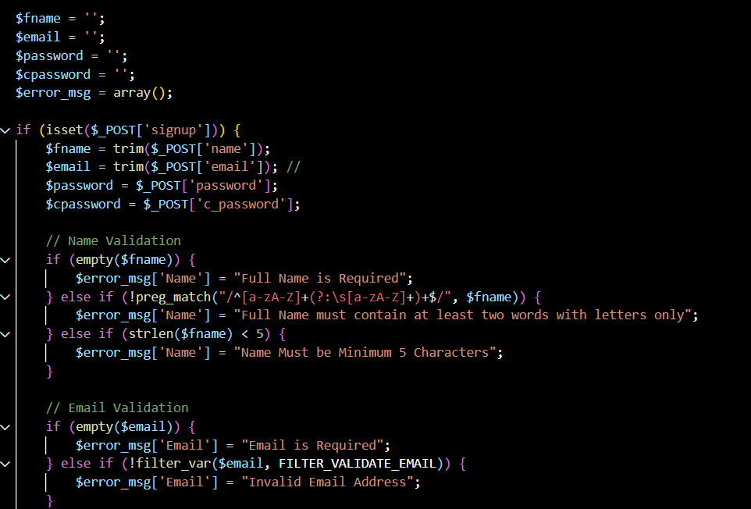

figure2. 1 Variable Naming

2.1.3 Arrays

Arrays are a fundamental data structure in programming, used to store a collection of elements, typically of the same data type. They are essential for managing lists of items and are supported by most programming languages. An array allows for efficient storage and retrieval of data using an index-based system.
2.1.4 Strings
Strings are sequences of characters used to represent text in programming. They are one of the most commonly used data types and can be manipulated using various string functions provided by programming languages.

2.2 Coding Standards
When developing an web based online learning system using a combination of JavaScript and PHP, We established a consistent coding standard to ensure maintainability, readability, and collaboration. Adhering to coding standards is crucial for maintaining code quality, readability, and consistency across a project. Proper coding standards enhance collaboration among developers and make the code base easier to maintain and debug.
Coding conventions serve the following purposes:
- They create a consistent look to the code, so that readers can focus on content, not layout.
- They enable readers to understand the code more quickly by making assumptions based on
- Previous experience.
- They facilitate copying, changing, and maintaining the code.

2.2.1 Comments
Comments are annotations in the code that help explain what the code does. They are not executed by the compiler or interpreter but are essential for providing context and explanations for future reference.

2.2.2Layout and indentation
Try-catch block is used to handle exceptions, which are errors or unexpected conditions that occur during the execution of a script. The purpose of the try-catch block is to allow you to catch and handle these exceptions, rather than letting the script terminate abruptly.
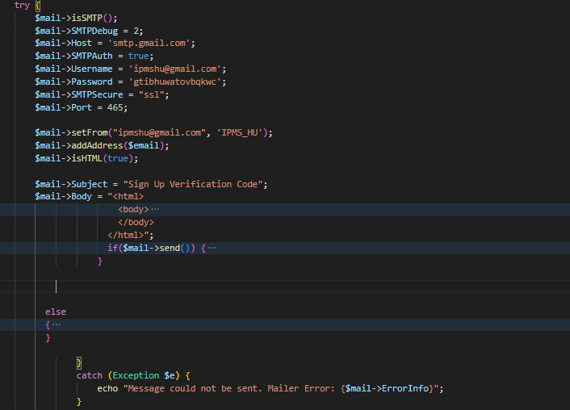
figure2. 2 Try catch

2.2.3 If else statements
If-else statements are structured to enhance readability. The conditions are clearly separated from the code block, and each block is indented appropriately.
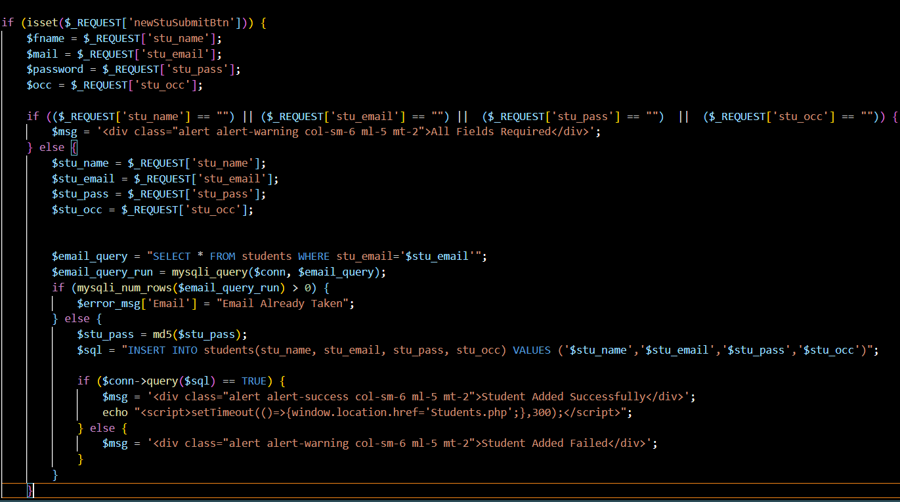
figure2. 3 If else statement

Chapter Three

Algorithm Design

3.1 Pseudo code
Pseudocode is a high-level, informal description of the steps required to solve a problem or implement an algorithm, written in a way that is independent of any specific programming language syntax. It is used to provide a human-readable representation of the logic and flow of a program without getting bogged down in the details of a particular programming language.
Pseudocode typically uses a combination of natural language, programming language constructs (such as if-else statements, loops, and functions), and descriptive variable names to convey the overall logic of the algorithm. The goal is to capture the essential steps and thought process behind the solution, making it easier to understand, communicate, and subsequently translate into actual code.
Pseudo code for registration for web based online learning platform
Begin
Variables:
- Student full name
- Email ID number
- Email
- Password
Then fill the login form
Click on sign up button
If (form is not filled)
Then system will ask please fill the required format
Else
If (Valid)
If it is valid then it create a database authentication and pass the queries
Then before inserting the user it makes validation and verifications
Else
If (email>0)
This this email is already registered!
Else you have successfully registered.
Pseudo code for login case of student:
Start:-
Variables
- Email:
- Password:
Then fill the login form
If (form is filled)
The system will checks its validity
If (Valid)
Generate database authentication process,
Then connect to MySQL database and pass the queries
If (any queries fails)
Display error message to the user “Invalid credentials”
Else
If they're correct
Create session
Display the page
Else
Display error message
Ask the user to refill the form
Pseudo code for Course Enrollment in Web-Based Online Learning System
Start:-
Variables
- Course ID
- User ID
- Enrollment Date
- Course Type: "Free" / "Paid"
Display the list of available courses to the user.
User selects a course to enroll in.
If (course is selected)
The system checks its validity
If (Valid)
Check course type
If (Course Type is "Free")
Generate database authentication process,
Then connect to MySQL database and pass the queries
Display success message: "Enrollment in free course successful."
Else If (Course Type is "Paid")
Display message: "Please proceed to payment."
If (Payment is successful)
Generate database authentication process,
Then connect to MySQL database and pass the queries
Display success message: "Enrollment in paid course successful."
Else
Display error message: "Payment failed. Please try again."
Else
Display error message: "Invalid course selection. Please select a valid course."
Else
Display error message: "Please select a course to enroll in."
End

Chapter Four

Testing Procedure
The software validation and verification framework is a comprehensive, structured approach that is integral to the software development lifecycle. It encompasses a meticulously planned sequence of actions and processes designed to rigorously evaluate and confirm the functionality, performance, and quality of a software application or system.

This validation and verification protocol involves a systematically designed series of steps aimed at identifying and addressing any issues or defects within the software. The test procedures are complete, self-contained, self-validating, and engineered to execute automatically, ensuring efficiency, consistency, and thorough coverage.

The validation and verification process encompasses a diverse range of test types, including unit tests, integration tests, system tests, and acceptance tests. This multifaceted approach enables a comprehensive examination of the software from various perspectives, ensuring that it meets the specified requirements and quality standards.

The validation and verification process is an iterative, cyclical endeavor, with continuous feedback and improvement mechanisms to enhance the overall quality and reliability of the software over time. It is tightly integrated with other phases of the software development lifecycle, such as requirements gathering, design, and deployment, ensuring a cohesive and well-coordinated effort.

By adhering to this rigorous validation and verification protocol, software development teams can deliver applications and systems that are reliable, functional, and aligned with the expectations of end-users. This comprehensive approach is a fundamental pillar in the pursuit of software excellence and the delivery of high-quality, robust software solutions

4.1 Testing plan
The testing plan outlines the approach, resources, and schedule for the testing activities. It includes the objectives, scope, and focus of testing. The goal is to identify and fix defects before the system goes live, ensuring it meets all requirements and functions correctly in the target environment.
The inputs for forming test plan include:

- Project plan
- Requirements document
- System design

4.2 Test Data
Login Test Data:
- Valid username and password.
- Invalid username and password.
- Empty username and password.
- Non-alphanumeric characters in username and password.

Performance Test Data:

Different hardware and software configurations.

4.3 Test Case Design
Test Case ID | Test Case Description | Success Criteria | Result
01 | Valid sign up details | User should be registered successfully. Verification email sent. | Passed
02 | Empty Name | Validation error: "Full Name is Required". | Passed
03 | Invalid Email | Validation error: "Invalid Email Address". | Passed
04 | Weak Password | Validation error: "Password Too Weak". | Passed
05 | Passwords do not match | Validation error: "Password Does not Matched". | Passed
06 | Existing Email | Error: "Email Already Taken". | Passed
07 | Name less than 5 characters | Validation error: "Name Must be Minimum 5 Letters". | Passed
08 | Name with non-alphanumeric characters | Validation error: "Name Must be Only Letter". | Passed

Table 4. 1 test case for student login
Test Case ID | Test Case Description | Success Criteria | Success or Fail
01 | Verify the successful addition of a new instructor with valid details. | Instructor is added successfully, and a verification email with login credentials is sent. | Success
02 | Verify the system's behavior with an invalid email format. | System displays an error message "Invalid Email Address". | Success
03 | Verify the system's behavior when the email is already in use. | System displays an error message "Email Already Taken". | Success
07 | Verify the password hashing functionality. | Password stored in the database is hashed. | Success
08 | Verify the email sending functionality for new instructor credentials. | Verification email with login credentials is sent successfully. | Success
09 | Verify the instructor can log in with the provided credentials after changing the password. | Instructor is able to log in successfully. | Success

Table 4. 2 test case instructor login

4.4 Testing Procedure
The software testing framework is a structured and methodical approach that outlines the guidelines and steps to be followed when conducting testing activities. These procedures serve as a road map to ensure that the testing process is planned, executed, and documented in a systematic and organized manner.
Adopting standardized testing procedures offers several benefits. It helps maintain consistency in the testing approach, allowing for better collaboration, knowledge sharing, and the establishment of best practices within the testing team. Furthermore, it enhances the efficiency of the testing process by providing a structured framework for test planning, execution, and reporting.

4.5 Integration Testing
Integration testing is a crucial phase in the software testing process, where individual software modules are combined and evaluated as a group. This testing approach is a systematic technique used to construct the program structure while simultaneously uncovering any errors associated with the interfaces between these modules.
The primary purpose of integration testing is to assess the compliance of the system or its components with the specified functional requirements. It serves as a bridge between unit testing, where individual modules are tested in isolation, and system testing, where the entire system is evaluated holistically.

4.6 System Testing
System testing is a crucial phase in the software development life cycle, where the quality assurance team evaluates the interaction and integration of the various components within the complete, integrated system or application. This testing approach focuses on assessing both the functional behavior and the quality attributes of the system, such as performance, security, usability, and so on.

Input | Expected Result | Actual outcome | Success/fail
All input have valid value | The users can login successfully | The users can login successfully | Success
In put field Email empty | The system display an error message “can not  be empty” | The system display an error message  “Email field cannot be empty” | Success
Input field password empty | The system display an error message “password field cannot be empty” | The system display an error message  “password field cannot be empty” | Success
Invalid  User name or password | The system display an error message “Invalid user name or password” | The system display an error message  “Invalid user name or password” | Success

Table 4. 2 system tasting

Chapter Five

Security Measures and System Maintenance

5.1 Database Security
Database security is a critical aspect of ensuring the integrity, confidentiality, and availability of data in a web-based online learning platform. This platform involves sensitive information, including user credentials, personal details, academic records, and communications between instructors and students. Therefore, securing the database is paramount to protect against data breaches, unauthorized access, and other security threats. Here are the key considerations and best practices for database security in this context

Authentication
Authentication refers to the process of verifying the identity of a user or client before granting them access to the system or data. This is a crucial aspect of database security and access control. The system uses various authentication methods to ensure only legitimate users gain access:
- Username and Password Login: The primary method of authentication, where users log in using a unique username and password.
- Anonymous Login: In some cases, users might have limited access without authentication, such as accessing public content.
- Multi-Factor Authentication (MFA): Adds an extra layer of security by requiring multiple forms of verification, a one-time passcode (OTP) during registration.

Authorization
Authorization involves controlling access to resources based on the user's identity and their assigned roles:
- Role-Based Permissions: Users are granted access to specific data and functionalities based on their roles (e.g., student, instructor, admin). This ensures that users can only access information and perform actions relevant to their roles.
- Fine-Grained Access Control: Implement detailed permission settings to control access to specific data fields and operations within the database.
Data Encryption
The use of bcrypt (via password_hash and password_verify functions) ensures that passwords are securely hashed and stored, providing strong protection against various attack vectors such as brute force and rainbow table attacks.

SQL Injection Prevention
SQL injection is a common attack vector that can be mitigated through:
Prepared Statements: Use prepared statements with parameterized queries to prevent SQL injection.

5.2 System security
In our web-based online learning platform, security is of utmost importance to protect sensitive information and ensure the integrity of the application. Several measures have been implemented to enhance the security of the system, ensuring a safe environment for all users.
- User Authentication:
Secure Passwords: The system requires users (both instructors and students) to create accounts with secure passwords. Passwords are stored using a robust hashing algorithm, specifically bcrypt, which protects against password breaches by incorporating salting and computational difficulty.
·Password Complexity and Updates: The system enforces password complexity requirements, ensuring that passwords are strong and difficult to guess. Additionally, users are prompted to update their passwords regularly to maintain the security of their credentials.
- Two-Step Verification:
Email Verification: After the initial login with a username and password, the system prompts the user to enter a one-time verification code sent to their registered email address. This adds an extra layer of security by verifying the user's identity through a second factor.
Secure Code Generation: The verification code is generated using a secure algorithm and has a limited validity period to prevent unauthorized access. This ensures that even if the verification code is intercepted, it cannot be used after its validity period expires.
- Session Management:
The system maintained secure user sessions, using techniques like session tokens, session timeouts, and session invalidation upon logout.
- Access Control:
The system implements RBAC to ensure that users can only access the functionalities and data relevant to their assigned roles (e.g., Instructor, Student, Administrator). This minimizes the risk of unauthorized access to sensitive information.The access control system should be regularly reviewed and updated to address changing requirements and potential security vulnerabilities.

features | Administrator | Instructor | Students | Guest
Login | ✓ | ✓ | ✓
Logout | ✓ | ✓ | ✓
View Profile | ✓ | ✓ | ✓
Edit Profile | ✓ | ✓ | ✓
Manage Course | ✓
Manage Educators | ✓
Manage Students | ✓ | ✓
Send Feedback | ✓ | ✓ | ✓ | ✓
View Available Courses | ✓ | ✓ | ✓ | ✓
Take Quiz |  |  | ✓
Track Progress | ✓ | ✓ | ✓ | ✓

Table 4. 3 Table showing Access control
- Confidentiality

Confidentiality is rigorously upheld within the web-based online learning platform to safeguard sensitive information. Personal details, academic records, and educational content of students are protected from unauthorized access using robust security measures such as encryption and strict access controls. Only authorized personnel, including administrators and educators, have access rights to manage and view this data, ensuring privacy and compliance with data protection regulations.
- Integrity
Integrity is fundamental to maintaining the accuracy and reliability of data and processes throughout the platform. It ensures that student grades, assessment results, and course materials remain consistent and unaltered. Through systematic validation checks, audit trails, and version controls, the platform ensures transparency and trustworthiness in all interactions and administrative functions, thereby enhancing user confidence and operational reliability.
- Availability
Availability is critical as the platform serves as a pivotal resource for uninterrupted access to educational resources and services. Designed for 24/7 availability, it supports flexible learning schedules and accommodates diverse user needs across different time zones. The platform employs redundant servers, load balancing techniques, and proactive monitoring to optimize performance and responsiveness, ensuring seamless access to learning materials and services even during peak usage periods.
In essence, the web-based online learning platform prioritizes Confidentiality to protect sensitive information, upholds Integrity to maintain data accuracy and transparency, and ensures Availability to provide uninterrupted access to educational resources. These principles collectively strengthen the platform's security, reliability, and usability, fostering a conducive environment for effective online learning experiences.
The Backup and Recovery Strategy of the web-based online learning platform integrates two primary backup methodologies: Full Backup and Incremental Backup.Full Backup entails creating a comprehensive duplicate of all system data and files at a specific moment. This method captures the entire data set in one operation, ensuring data integrity and completeness. However, due to its thoroughness, full backups can be time-consuming and necessitate substantial storage capacity.In contrast, Incremental Backup selectively archives only the changes or additions made since the last backup, whether it was a full backup or a previous incremental backup. This approach significantly reduces backup time and conserves storage space by focusing solely on new or modified files. However, restoring data from incremental backups may involve retrieving multiple backup sets to reconstruct the complete data set accurately.

The platform's Backup Strategy is tailored to combine these backup types to optimize efficiency and meet operational requirements. For instance, administrators might execute periodic full backups complemented by frequent incremental backups, scheduled daily or hourly. The choice between backup types considers factors such as data volume, frequency of alterations, recovery objectives, and available infrastructure resources.
This strategic approach ensures that the platform maintains robust data protection, minimizes downtime risks, and supports swift data recovery in case of system disruptions or data loss incidents. Regular testing and validation of backups further reinforce the platform's resilience, ensuring seamless continuity of educational services and administrative operations.

Chapter 6

User Training, User Manual and Installation Manual

6.1 User Training Plan
The user training plan aims to ensure all stakeholders—administrators, educators, learners, and guests—are proficient in utilizing the web-based online learning platform effectively. It focuses on equipping them with the necessary skills to navigate the platform's features, manage tasks efficiently, and troubleshoot issues when needed.
The primary objective of the User Training Plan is to ensure that all stakeholders can proficiently navigate and utilize the web-based online learning platform to achieve their respective goals. Administrators will learn to manage courses, users, and system configurations efficiently. Educators will gain insights into creating engaging learning materials, managing students, and evaluating their progress. Learners will be equipped to enroll in courses, access materials, participate in quizzes, and interact within discussion forums. Guests will understand how to browse courses, provide feedback, and explore available resources

6.2 User Manual Document
The Web-Based Online Learning Platform is an innovative application designed to facilitate seamless learning experiences for administrators, educators, learners, and guests alike. This user manual serves as a comprehensive guide to help you navigate and effectively utilize the platform's key features and functionalities.
The platform provides an intuitive interface tailored to meet the diverse needs of its users. Administrators can manage courses, user roles, and system settings with ease. Educators can create engaging learning materials, assess student progress, and foster interactive learning environments. Learners have access to a wide range of courses, interactive content, quizzes, and discussion forums to enhance their educational journey. Guests can explore available courses, provide feedback, and engage with platform resources.
Here are the Manual for the login in the case of the student:
Key Highlights:
Home page
homepage serves as a central hub for accessing educational resources and information. It features several key sections for navigation:
- Header Navigation: Located at the top of the page, includes links to Home, Courses, Blogs, Forum, Contact, About, and Join For Free.
- Main Banner: Prominently displays the message "Grow your Skills to Advance your Career path" and emphasizes the importance of education.
- Categories Section: Organizes content into distinct categories, facilitating easy access to various topics without specific subject mention.
- Popular Courses: Highlights courses available for enrollment, providing details such as course name, instructor, and enrollment numbers.
- Student Reviews: Showcases feedback from students, demonstrating their experiences and insights without specific subject mention.
- Awesome Features: Lists notable features of Ethio Learn, including scholarship facilities and global recognition.

- Footer: Contains essential links such as quick navigation, contact information and others

This structure ensures that users can navigate seamlessly through the homepage to find relevant educational content and resources.



Figure6. 1 home page

Student registration

Sign Up
- Go to the sign-up page (e.g., signup.php) and fill in the form: enter your full name , email address, password (8-12 characters, at least one letter and one number), and confirm the password. Click "Sign Up".
- The server validates your input, checks email uniqueness, and sends an OTP to your email if valid. You'll be redirected to the OTP verification page.

Email Verification
- On the OTP verification page (e.g., verify_otp.php), enter the OTP from your email and click "Verify".
- The server checks the OTP. If valid, your email is verified and you'll be redirected to the login page. Errors will be displayed if the OTP is incorrect or expired.

Log In
- Go to the login page and enter your registered email address and password. Click "Sign In".


Dashboard and Navigation:
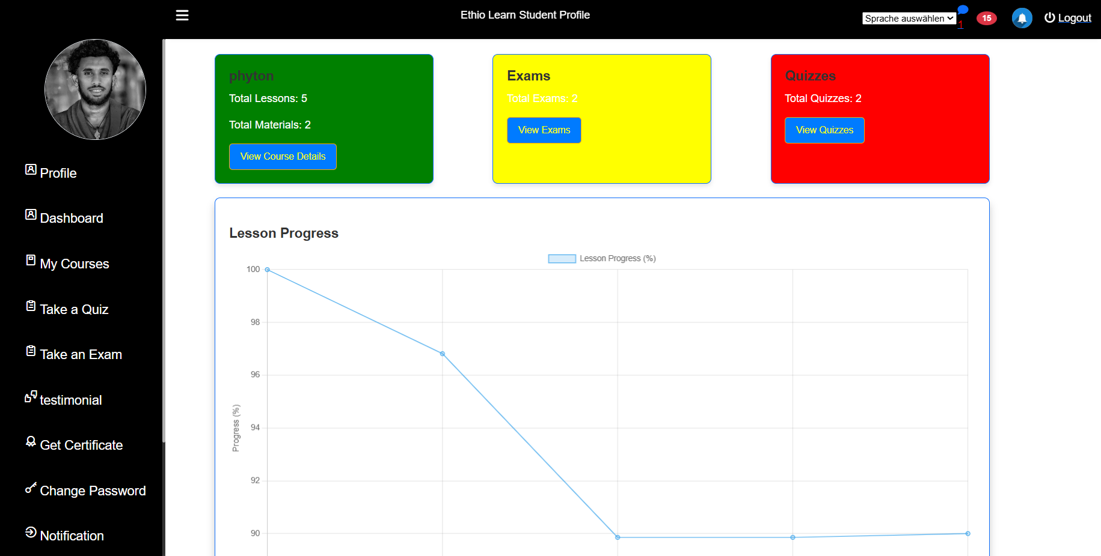
The dashboard has a navigation menu on the left side, you'll find a menu where you can access your profile details, view courses you've enrolled in, take quizzes and exams, provide feedback through testimonials, and download certificates you've earned. You can also change your password, check notifications for updates, read messages, and view important notices. In the main dashboard area, you'll see summaries of your course progress, including total lessons, materials, exams, quizzes, and your progress in each lesson. If you need to switch languages, simply select your preferred language at the top.to log out securely when you're done.

Figure6. 2 Student panel

6.3 Installation Guide
Here is some important process that guide the user how to install the system from the internet.
· Configure Apache Server:
· Open XAMPP Control Panel.
Start Apache server if it is not already running.
· Access Ethio Learn: Open a web browser and enter the following URL in the address bar: http://localhost/ethiolearn
· · Follow Installation Instructions: Follow the on-screen instructions provided by Ethio Learn to complete the installation process. This may involve setting up a database, configuring initial settings, and creating an admin account.
· · · Remark Internet connection must be mandatory since we have a two factor authentication system.

Chapter Seven

7.1 Conclusion
The development of our web-based online learning platform marks a significant milestone in modernizing and enhancing educational accessibility in Ethiopia. This platform effectively addresses the growing demand for flexible, accessible, and quality education by leveraging the power of the internet and digital technologies. Our journey through the design and implementation phases has demonstrated the potential of such platforms to transform traditional learning environments, offering a more inclusive and adaptable educational experience.
Our web-based online learning platform provides students with the ability to access educational materials from anywhere and at any time. This is particularly beneficial for those in remote or underserved regions, effectively bridging the educational divide. The platform prioritizes user experience, ensuring that both students and educators can navigate and utilize its features with ease. The intuitive interface, along with comprehensive support resources, enhances user satisfaction and engagement. Furthermore, implementing secure sign-up and login processes, including email verification and OTP authentication, ensures that user data is protected, thereby fostering a safe learning environment.
The platform is multilingual, offering content in Amharic, English, and Affan Oromo, which enhances accessibility and inclusivity for Ethiopian users. Additionally, Ethiopian cultural elements, such as color schemes and design aesthetics, were thoughtfully incorporated into the interface to ensure cultural relevance and user comfort.
By integrating multimedia resources, interactive quizzes, and real-time feedback mechanisms, our web-based online learning platform makes learning more engaging and effective. This approach not only facilitates better understanding but also retains students' interest. The platform is designed to accommodate a growing number of users and a diverse range of courses. Its scalable architecture ensures that it can evolve with the increasing educational demands and technological advancements.
Throughout the development process, several challenges were encountered, including technical issues, user feedback integration, and maintaining a balance between feature richness and simplicity. These challenges provided invaluable lessons in project management, user-centered design, and agile development methodologies. Looking ahead, our web-based online learning platform is poised for continuous improvement and expansion. Future enhancements could include advanced analytics for personalized learning, integration of AI tutors, and broader course offerings in various languages. By staying attuned to user needs and technological trends, the platform can sustain its growth and impact in the educational sector.

7.2 Recommendation
To further enhance the effectiveness and user experience of our web-based online learning platform, several key recommendations are proposed:
Diverse Assessment Methods: Expand assessment options to include a variety of methods such as assignments in addition to quizzes and exams. This diversity will cater to different learning styles and provide a more comprehensive evaluation of student progress and understanding.
Enhanced Interactive Elements: While the platform includes discussion forums, blogs, and notifications, adding features such as live streaming classes, real-time polls, and virtual labs can significantly enrich the learning experience. These additions will create a more dynamic and engaging educational environment.
Course Classification by Level: Implement a structured course classification system based on difficulty levels (beginner, intermediate, advanced) and user ratings. This will help learners easily find courses that match their skill level and learning needs, facilitating a more organized and efficient learning journey.
By implementing these recommendations, our web-based online learning platform can continue to thrive and evolve, providing an exceptional educational experience for all users. Prioritizing cultural relevance, technological innovation, and user-centric design will ensure that the platform remains a valuable tool for education in Ethiopia.

References
[1] PHP. (2023). PHP Documentation. [Online]. Available: https://www.php.net/docs.php
[2] Bootstrap. (2023). Bootstrap Documentation. [Online]. Available: https://getbootstrap.com/docs/5.0/getting-started/introduction/
[3] MySQL. (2023). MySQL Documentation. [Online]. Available: https://dev.mysql.com/doc/
[4] W3Schools. (2023). HTML/CSS Tutorial. [Online]. Available: https://www.w3schools.com/html/
[5] GitHub. (2023). GitHub Documentation. [Online]. Available: https://github.com/
[6] README. (2023). README.md Guide. [Online]. Available: https://www.makeareadme.com/

